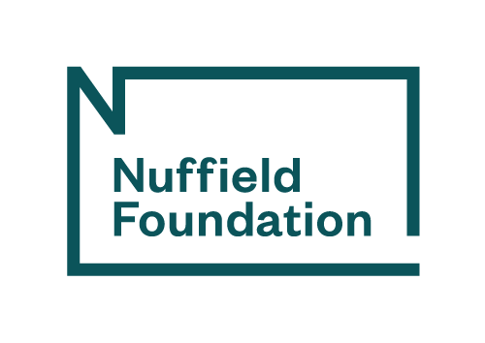

Appendix C: Communications plan template

This template should only be completed after reading the ‘Communications, stakeholder engagement and impact’ section of the
Guide for Grant-holders.
Please follow this guidance for completing the template below:
- The first step is to think about the overall aims of your project. What difference do you want it to make?
- Next, think through key audiences for the project. Although your project might be relevant to many groups, you should focus most of your resources on two to four key audiences. These could include a broad group like policymakers and more specific ones such as an industry or organisation.
- You should then think through your main objectives for each of the key audiences. These could include changing practice, changing policy or raising awareness. You can have more than three objectives but be realistic about your capacity.
- The next step is to identify the messages you will need to convey to achieve each of your audience-specific objectives. You might not be able to identify specific messages at an early stage in your project, so you should update this document as your research progresses.
- Consider the types of outputs and channels which are best suited for sharing each of your messages to each of the relevant audiences. Outputs can include reports, journal articles, newspaper articles, podcasts, zines and so on. Channels could include specific publishers and platforms as well as organisations you could partner with to amplify your messages.
- Indicate the date or stage of your project at which you intend to achieve each audience-specific objective. Again, it might not be possible to do this precisely at an early stage in your project, so update this column as things progress.
- Think about how you can evaluate your success against your audience-specific objectives using quantitative or qualitative measures.
- Try to identify potential spokespeople who can amplify your messages and wider support that you might be able to access.
- Finally, specify who will lead on and support the delivery of your communications plan, and give details of any additional funding or resources you may be able to access for delivering your communications plan through your project team’s institution(s)/organisation(s).

Main public output
You are required to publish a Main public output (MPO), including an executive summary which can work as a standalone document, before the end date of your project. For detailed guidance on the MPO, please refer to section 4.6 of the Guide for Grant-holders. If you have any questions after reading it, please reach out to your Grant Coordinator and Grant Lead. You should allow eight weeks after the submission of your draft MPO to the Nuffield Foundation for review and redrafting. Your MPO could be included as an output against several of the objectives below.

Updating the plan
The communications plan should be updated throughout your project. If a new opportunity presents itself, you uncover novel findings, or you realise that there are better ways to reach your intended audience, please update the document and send it to your Grant Coordinator.

Costs
We don’t expect you to list the specific cost of producing and publishing each output. However, you should consider whether the amount of money budgeted for communications and engagement in your approved budget is sufficient to cover the activities listed below.

Accessibility
You should consider whether your outputs are accessible for different audiences. This includes thinking carefully about your choice of font, format and colour scheme. Videos with audio must have subtitles or closed captions available.
Please refer to the Government Communication Service’s guide on planning, creating and publishing accessible social media campaigns for information on how to improve the accessibility of your outputs.

Aims
What difference do you want this project to make?

Audience 1: [ENTER HERE]
Objective | Messages | Relevant outputs | Channels | Date/stage | Evaluation
1)
2)
3)
Audience 2: [ENTER HERE]
Objective | Messages | Relevant outputs | Channels | Date/stage | Evaluation
1)
2)
3)
Audience 3: [ENTER HERE]
Objective | Messages | Relevant outputs | Channels | Date/stage | Evaluation
1)
2)
3)
Audience 4: [ENTER HERE]
Objective | Messages | Relevant outputs | Channels | Date/stage | Evaluation
1)
2)
3)

Spokespeople
Identify who can be interviewed about the project, be quoted, write articles etc. Spokespeople don’t need to be active throughout the whole project, but they should champion your key messages whenever possible. The spokespeople can be for a specific audience or for the larger outcomes of the project.
Support
Who will lead on the delivery of your communications? Please also describe any support, additional funding or other resources you can access for this through your project team’s institution(s)/organisation(s).

