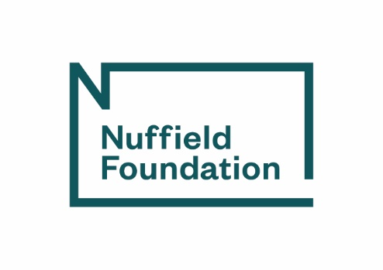

Progress report
Please complete and email to your Grant Administrator
Text in italics is for guidance only and may be deleted

Grant ref: | This is the reference provided in your Confirmation of award letter
Date of report:
Project title:
Name of Principal Investigator (PI):
Organisation name: |  | Including university department name, if applicable.
Project progress to date: Please provide details about how your project is going, including an assessment of whether it is running to the original timetable (or otherwise agreed with the Foundation).

How has your project advisory group been involved in the project? Please provide details about meetings held since your last update, future meetings planned and how the group has been contributing to the project.

Who is a member of your project advisory group? Please provide their names, organisation and area of expertise/experience.

What has gone well? Please provide details of the successes to date.

What challenges have you encountered? How have you overcome these challenges?
Please provide details.

Have any circumstances led to changes from your original plans? Please provide full details. If you need to request changes to your grant, please complete the Change request form (available on our website here).

What are your key findings? (If applicable) Please provide brief details about any findings from your project to date.

Please provide details of any project publications and other dissemination activities to date Please include the date and reference of publications (with web link if available), and details of the purpose and impact of activities, including any media coverage. These details should also be included in your Communications plan.

What impact has your project had to date? Please provide details of any impact your project may have had to date.
Please provide details of any upcoming project publications or dissemination activities. Please include the expected date, publication source, target audience, plans for press activities and proposed date for sharing drafts with the Foundation. These details should also be included in your Communications plan.

Nuffield Foundation response/queries:

PI reply to Nuffield Foundation responses/queries

Office use only
Status:
☐ | Approved
☐ | Pending
☐ | Completed
Date:
Initials:

