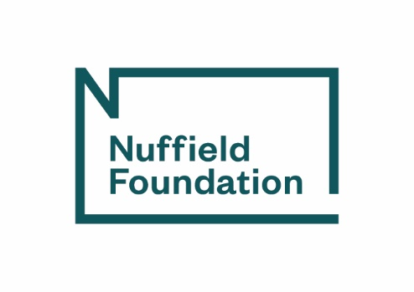

Change request form
Please complete and email to your Grant Coordinator
Text in italics is for guidance only and may be deleted

Grant ref: |  | This is the reference provided in your Confirmation of award letter
Date of request:
Project title:
Name of Principal Investigator (PI):
Organisation name: |  |  | Including university department name, if applicable.
What type of change are you requesting? Please select all that apply
☐ | Project scope or approach (e.g. sampling, sample size/coverage, analysis plans, availability of data)
☐ | Outputs and dissemination plans
☐ | Staffing
☐ | Timetable (including grant end date)
☐ | Budget transfer
☐ | Something else (please specify):
Is this change requested as a result of the Covid-19 outbreak?
☐ | No
☐ | Yes – please provide details below about how the advisory group has been involved.
What is the nature of the change? Please provide a clear description of the change you wish to make.

Why are you requesting this change? Please provide full details about the reason for the request.

What are the implications of this change for other aspects of the project? Please provide details – this should include implications relating to how the research questions will be answered and any changes to your plans for research outputs/dissemination or impact.

What, if any, financial implications are there of this change? Please provide full details.

What, if any, timetable implications are there of this change? Please provide full details, if not covered above.

Has the project advisory group been consulted about the requested change(s)?
☐ | No
☐ | Yes – please provide details below about how the advisory group has been involved.

Nuffield Foundation response/queries:

PI reply to Nuffield Foundation response/queries:

Office use only
Status:
☐ | Approved
☐ | Pending
☐ | Declined
Date:
Initials:

