MATHS TEST

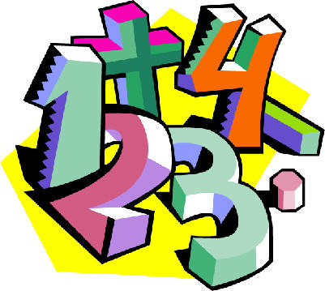

NAME: …………………...

CLASS: ………………….
For the first part of the test, the teacher will read out the question, and you will need to tick the correct box to show which calculation is being shown in the question.

Question 1

George has 15 sweets but he gives 4 sweets to his sister. How do you work out how many sweets George has left? (Tick one box)

15 + 4
15 ÷ 4

15 - 4
15 × 4

Question 2

Six children are holding two books each. How do you work out how many books they have altogether? (Tick one box)

6 + 2
6 - 2

6 × 2
6 ÷ 2

Question 3

Eight sweets are shared between four children? How do you work out how many sweets each child gets? (Tick one box)

8 + 4
8 - 4

8 × 4
8 ÷ 4

Question 4

It takes Chris 4 minutes to wash a window. He wants to know how many minutes it will take him to wash 8 windows at this rate. Which of these should he do? (Tick one box)

4 × 8
8 ÷ 4

8 - 4
8 + 4
For the second part of the test, the teacher will read out all the questions. Sometimes you will need to tick the correct box, and sometimes you will need to work out and write down your answer.

Question 5

What is 5 times 2?

7
3

10
52

Question 6

Work out what 8 times 5 is. (Write down your answer)

Question 7

A class full of children lined up in four rows. There were seven children in each row. How many children were there in the class? (Tick one box)
28
18
12
11

Question 8

What is 3 times 23? (Tick one box)
323
233
69
26

Question 9

Maurice the monkey eats one bunch of bananas every day. If there are six bananas in a bunch, how many bananas does Maurice eat in a week? (Tick one box)
7
30
36
42

Question 10

25 × 18 is more that 24 × 18. How much more? (Tick one box)
1
18
24
25

Question 11

A boat moves at 2 metres every second. How far does it move in 7 seconds?
9
14
5
7

Question 12

If you know that 18 × 4 = 72, how would you work out 18 × 3? (Tick one box)

18 + 3
72 + 18

72 - 18
72 - 3

Question 13

Emily swims four times further than James. If James swims four lengths of the pool, how many lengths does Emily swim? (Tick one box)
16
8
2
12

Question 14

When Sarah’s guinea pig was born, it was only six centimetres long. It grew up to be three times this size. How big did it grow to?
9
12
36
18

Question 15

Calculate 14 × 6 (write down your answer)

Question 16

A shop makes sandwiches. You can choose from 3 sorts of bread, and from 6 sorts of filling. How do you work out how many different sandwiches you could choose?

6 + 3
6 × 3

6 - 3
6 ÷ 3

For the last part of the test, the teacher will read out the question, and you will need to look at the pictures in the questions so that you can answer the question.

Question 17

Look at the picture below:

Fill in the boxes below to show the calculation that is in the picture:

× =

Question 18

Look at the picture below:

Fill in the boxes below to show the calculation that is in the picture:

× =

Question 19

Look at the picture below:

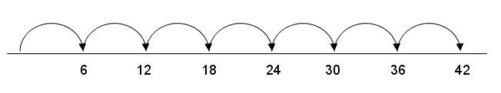
Fill in the boxes below to show the calculation that is in the picture:

× =

Question 20

The picture below shows four cups. Each cup is hiding six sweets.

Fill in the boxes below to show the calculation of the number of sweets in the picture:

× =

Question 21

The picture below shows a piece of card with rows of circles. The bottom of the piece of card is hidden behind a screen. Four rows of circles are hidden by the screen.

Fill in the boxes below to show the calculation that is in the picture on the card when the screen is taken away:

× =

WELL DONE
FOR DOING
THE TEST!

