Observing osmosis, plasmoylsis and turgor in plant cells

Investigation
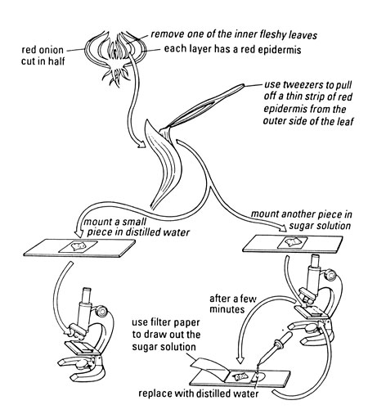
- Get a single layer of plant cells. If you are using red onion, cut a 1 cm square from a fleshy piece of onion and then peel off a single layer of the red cells. If you are using rhubarb, peel a piece from the epidermis. If you are using toadflax peel a piece of the lower epidermis of a leaf.
- Place the strip on a slide and cover it with a drop or two of distilled water. Add a cover slip.
- Look at the cells through a microscope. Start with the low power lens. Draw and label 3 plant cells.
- Take another strip of cells from your plant material. This time mount the cells on a slide with 5% sodium chloride solution.
- Examine the cells through the microscope. Draw and label 3 plant cells.
- After a few minutes draw out the sodium chloride solution with a piece of filter paper placed at the edge of the coverslip. Replace it with distilled water added at the other side of the coverslip.

QUESTIONS
- Describe the cells in distilled water. How are the cells in 5% sodium chloride different from this? Describe what happens when you take away the sodium chloride solution and add water.

- Explain what happened to the cells in sodium chloride solution using biological terms.
Try to include these words.
cytoplasm
diffusion
water
solvent
dissolved salts
solute
cell membrane
vacuole
cell wall
osmosis
plasmolysis
turgid
flaccid
turgor
- Explain what happened to the cells when you replaced the surrounding sodium chloride solution with water. Try to include the words from the list again.

- What prevents the plant cells from bursting when they take in lots of water?

- You’ve seen what happens to cells in epidermal tissue when they lose water. How does a whole plant look when it is short of water? How does it change when you give it water? Try to explain these observations using the ideas above.

- Animal cells do not have the same structure as plant cells. What do you think could happen to an animal cell in water?

- What would you do to investigate this process further?
ANSWERS
- Cells in distilled water show no gaps between the cytoplasm and the cell wall, and may show a clear vacuole. In 5% sodium chloride, the cytoplasm is contracted and there is a gap between the cytoplasm and the cell wall. When you take away the sodium chloride and add water, the situation returns to the initial state.

- The cytoplasm contains salts at a concentration greater than that of distilled water (zero) and less than the sodium chloride solution (5%). Because of this difference in concentration of solute, water (the solvent) diffuses through the cell membrane from the area of lower concentration to the area of higher concentration – this is osmosis. In 5% sodium chloride solution, the cell loses water to the point where the vacuole becomes reduced and the cytoplasm comes away from the cell wall. The cell is now plasmolysed and the body of the plant would be flaccid.

- Therefore, in distilled water the solvent diffuses through the cell membrane from the area of lower concentration (outside) to the area of higher concentration (inside). This is osmosis again and the plant cell absorbs water to the point where it can absorb no more. The cell is now turgid and the cell wall prevents the cell from bursting.

- The cell wall prevents the cell from bursting.

- When a whole plant is short of water, all its cells are flaccid and the whole plant wilts or droops. When you give it water, all the cells become turgid again and the plant stands up properly. Water is important to the physical strength and rigidity of plant material.

- Because animal cells do not have a cell wall, they can burst in dilute solutions.

- Place animal cells in different concentrations and see how they react. However, the process will not be reversible, because once burst, the cells cannot reform.

