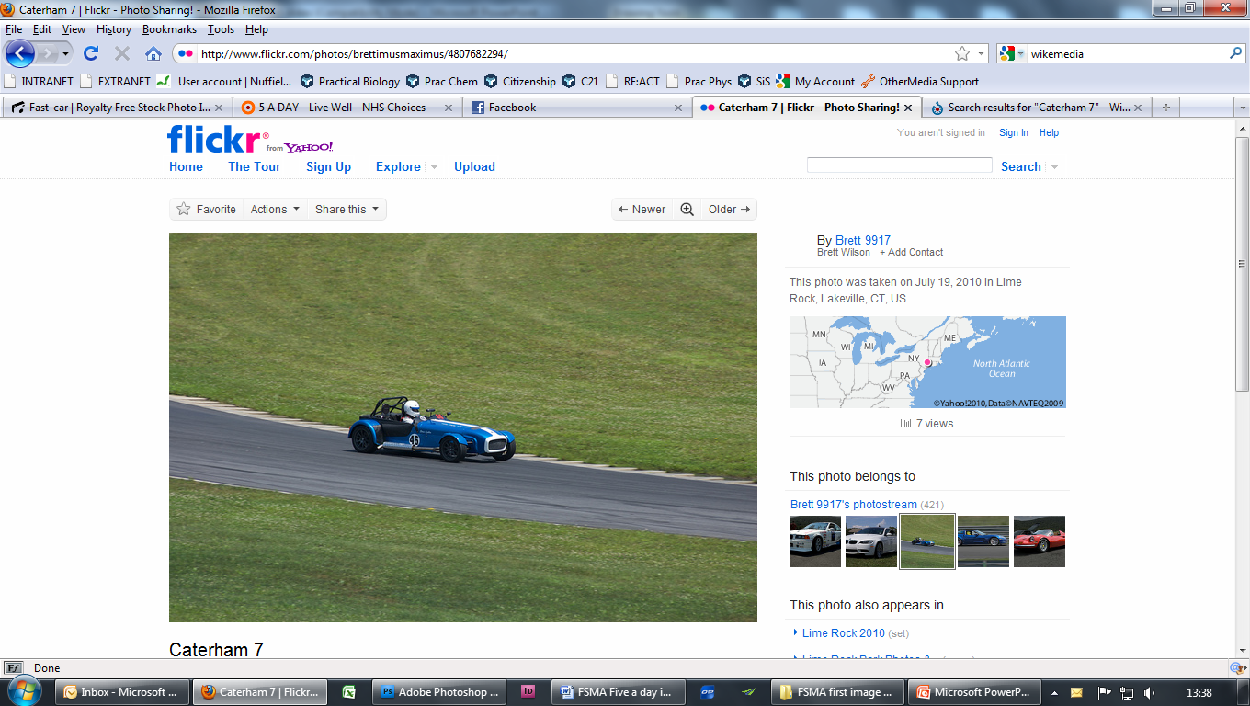The time taken for a car to accelerate from rest to 60 mph is one of the performance figures used to compare cars.

Many factors affect the acceleration of a car, making a full theoretical model extremely complicated. Often a simpler model is sufficiently accurate.

You will model the motion of a car by fitting linear and quadratic functions to a graph of actual data recorded in a test run.

Models of the motion of cars can be useful in many fields, including car design, video games, traffic management, and in litigation.

Information sheet

Think about

Why do we model data with a function?

The speed of a car during the first 16 seconds of a test run was recorded at intervals of 0.02 seconds. The graph of speed against time is shown below.

Think about

What do you notice about the shape of the graph?

What does the gradient of the graph represent?

Why doesn’t the speed of the car constantly increase?

Worksheet Modelling data

Try these

Information from the graph

**1** Use the graph to find:  
**a** the maximum speed reached by the car  
**b** the time taken for the car to accelerate from 0 to 60 miles per hour.

**2** The car changed gear three times during the time interval shown on the graph. Find the times at which these gear changes occurred.

Modelling the data with linear functions

**3** Find linear functions to model the speed of the car during each of the following time intervals:

**a**  **b**  **c** 

**4** Use your functions to estimate the speed of the car at a time half-way through each interval. Compare your results with the speeds shown on the graph.

Modelling the data with a quadratic function

**5** Find a quadratic function to model the speed of the car during the interval 

**6** The original data and the graph are in the Excel file   
Test run spreadsheet.xls.

Add another column to the spreadsheet to show the speed predicted by the model for each time value used. Add this series of values to show the model on the graph.

**7** Print the graph. (Do not print all the data.)

Compare the graph of your quadratic model with that of the original data.

Reflect on your work

Think about the methods you used and the models you produced. Could you have used another method? Which model do you think is the most suitable?

Extension

Are different models more suitable for different ranges of the data?

Could you refine the models by combining your linear models and quadratic model?

What are the advantages and disadvantages of the different models?