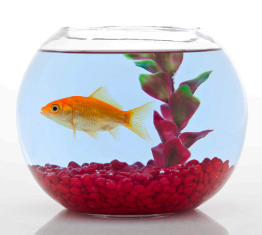
Introduction
This activity will give you practice in changing the subject of a formula.
Information sheet
Goldfish need oxygen in their water. The amount of dissolved
oxygen depends on the surface area of the water.
Each fish needs 24 square inches of water surface.
What is the minimum radius of a bowl for 5 fish?
The surface is a circle with area A = πr², but in this case it is
r that is needed. It is useful to rearrange the formula to make r the subject.
Rearranging a formula
This is a step-by-step process by which you move terms from one side of the formula to the other. You may find the following guidelines helpful.
- Aim to remove all the terms except the new subject from one side of the formula, so that the subject is left on its own.
- To remove a term, use the inverse operation.
For example, to remove + mv², subtract mv² from both sides.
- Often you need to simplify or remove fractions before starting to rearrange the terms. Do this by removing brackets or multiplying by a number.
- If the subject is in the denominator of a fraction, multiply both sides by the denominator to bring the subject to the top.
- If the subject is in more than one term, bring these terms together at one side; then put the subject outside the bracket as it will be a common factor. Then divide by the terms inside the bracket.
- If the subject is in a square root, isolate the square root,
then square both sides.
Area of a circle
r
Starting with the formula A = πr²
To make the subject r 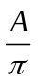 = r²
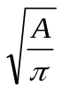 = r so r =
Now, back to the goldfish!
Each fish needs 24 square inches, so 5 fish need 5 × 24 = 120 square inches
r = 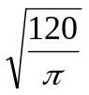 = 6.2 inches

Equation of a straight line y = mx + c
To make the subject c y – mx = c
m = gradient
c
x
y
0
So c = y – mx
To make the subject x y – c = mx
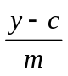 = x
So x = 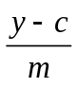

Area of a trapezium A = 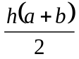
a
b
h
To make the subject h 2A = h(a + b)
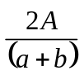 = h
So h = 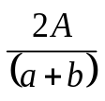
To make the subject a 2A = h(a + b)
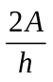 = a + b
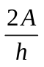– b = a
So a = – b
Total resistance in an electrical circuit R = 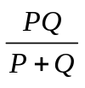
To make the subject P R(P + Q) = PQ
P
Q
RP + RQ = PQ
RQ = PQ – RP
RQ = P(Q – R)
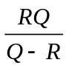 = P
So P =

Try these
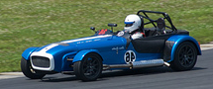
1 The speed of a car after t seconds is given by the formula v = u + at
where u is the starting speed and a is the acceleration.
Rearrange this formula to make the subject:
a u b t

2 In an electrical circuit, the formula relating power, P, to the current, I, and resistance, R, is P = I²R.
Rearrange this formula to make the subject a R b I

3 If a ball is thrown up in the air at a velocity of v, the height it reaches is given by 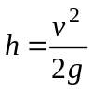 where g is the acceleration due to gravity.
Rearrange this formula to make the subject v.

4 A formula for converting temperatures is 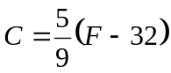
where C is the temperature in degrees Celsius, and F is the temperature in degrees Fahrenheit.
Rearrange this formula to make the subject F.

5 When a car accelerates steadily from a speed u to a speed v in time t,
the distance it travels is given by: 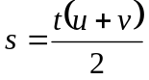.
Rearrange this formula to make the subject a t b v
r
6 The volume of a sphere of radius r is given by the formula 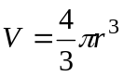
Rearrange this formula to make the subject r.

7 When the speed of a car increases from speed u with acceleration a over a distance s, its final speed is v where: v² = u² + 2as.
Rearrange this formula to make the subject a s b u

8 When the speed of a car increases from speed u with acceleration a,
the distance it travels in time t is given by: s = ut + at².
Rearrange this formula to make the subject a a b u

9 The time taken for a pendulum of length l
to make one full swing is 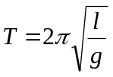
where g is the acceleration due to gravity.
T seconds
string
l
metres
Rearrange this formula to make the subject l.
mass

10a The volume of a cylinder is given by the formula V = πr²h
where r is the radius and h is the height.
Rearrange this formula to make the subject r.
h
r
b The formula for the total surface area of the cylinder is S = 2πr(r + h)
Rearrange this formula to make the subject h.

11 The area of a washer is given by the formula A = π(R² – r²)
where r is the inner radius and R is the outer radius.
Rearrange this formula to make the subject r.
r
R

12a The volume of a cone with radius r and height h is given by V = πr²h.
Rearrange this formula to make the subject r.
h
r
b The formula 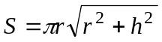 gives the area of the curved surface of the cone.
Rearrange this formula to make the subject h.

13 When an object of mass m, moves with velocity v at height h,
its total energy is 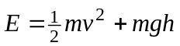.
Rearrange this formula to make the subject a v b m.

14 If a principal £P earns simple interest at a rate of R% per annum,
the total amount after T years is given by the formula 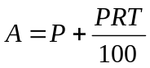.
Rearrange this formula to make the subject P.

15 When an amount of money, £P, is left in a building society account
that gives r% interest per annum, the amount in the account after n years
is given by the formula 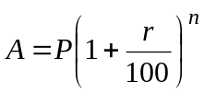.
Rearrange this formula to make the subject r.

16 If the monthly rate of interest on a loan is m %, the annual percentage rate (APR) is given by: R = 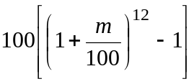.
Rearrange this formula to make the subject m.
At the end of the activity
- The area of the water surface in the goldfish bowl is given by A = πr².
Re-write this formula to make the subject r.
- When rearranging a formula, how do you decide which term to move first?
- What do you do if the subject is in the denominator of a fraction?
- What do you do if the subject appears twice?

